**StarContests.com**

### *If it’s not here, it’s not happening.*

***User Manual v1.1***

***Team 8***

**Instructor - Prof. Asim Banerjee**

**Group members**

|  |  |  |
| --- | --- | --- |
| **Serial No.** | **Name** | **ID** |
| 1. | HARDIK BELADIYA | 201201064 |
| 2. | ARCHIT GAJJAR | 201201066 |
| 3. | SOHAM DARJI | 201201070 |
| 4. | KRUPAL BAROT | 201201074 |
| 5. | DHAVAL CHAUDHARY | 201201075 |
| 6. | PRACHI KOTHARI | 201201077 |
| 7. | YASH KUMAR JAIN | 201201080 |
| 8. | RACHIT MISHRA | 201201092 |
| 9. | SHIVANI THAKKER | 201201108 |

**DOCUMENT DETAILS:**

|  |  |  |  |  |
| --- | --- | --- | --- | --- |
| **Document** | **Date** | **Version** | **Created By** | **Reviewed By** |
| **User Manual** | **9 April 2015** | **1.0** | **Archit Gajjar, Rachit**  **Mishra** | **Krupal Barot** |

**1.  Introduction**

Our main aim behind the project is to provide platform for local contest organizers who don’t have their own website for creating and managing event and for local talents to know about contests happening around them of their field of interest.

**1.1 Purpose**

The user manual helps the users (end users and the client (admin)) to understand the functionalities of the product. All the features of the software are explained in this document. This will enable the user to easily understand the working and use the software in an efficient manner.

**1.2 Motivation**

1) The main motivation of this project is to make the contest management easy and efficient for the Organizers and easy to register for participants.

2) Easy to make fixtures for contest and manage them.

     3) If there’s change in event all registered users are informed

     4) Local talent encouragement

5) Providing all details about contest to all users

**1.3 Document overview**  
this document, aims at helping the user in understanding the use of this Application, its workflow and how to use it efficiently and effectively. The Document explains them functionalities of all tabs, buttons and menu options Available to the users of various profiles

**2. Support**

**2.1 System requirements**

StarContests.com, our website connects the local talent and organizers. Everyone needs a platform to prove their ability. Even we need much support to conduct and contest. So basically our main motto is to provide such a platform which satisfies requirement of both.

**The specific UI requirements from our website would include-**

1. Creating a search functionality, which is easy to use

2. Creating a rating/ranking system, which is self-stabilizing in itself

3. Create a profile page for all type of users, which can be edited by them easily.

4. User can mark its favourite contest to obtain regular news/update of marked and interested contest.

In discussion with the team, we have developed a proper understanding of the requirements- layouts of basic modules, and discussed appropriate front-end features. We have tried to make the interface design a balanced mixture of the sober and extravagant.

Our approach to designing the User Interface was to create a system which is as user friendly as possible. We have also tried to improve the user experience by making pages dynamic using JavaScript. We have tried to keep the user interface soothing by keeping it simple.

We first started working on the basic header which included a navigation bar, and basic search box, and sign in / sign up buttons. We further moved on to different independent modules, and started developing them concurrently. These modules involve the Sign-in/ Sign-up modules, profile modules, ranking/rating modules, favorite modules. After the basic pages were set up (base lined state, in the language of our SDLC module), we have shifted to making the pages dynamic, more soothing, and with better user experience. This is the basic UI design approach we have been following in the entire Designing and Developing phase of our Concurrent Development SDLC module.

**2.2 User Side-**

1. 1GHz Intel or AMD, 400 MHz ARM processor

2. 256 MB of memory

3. JRE

4. 800 x 600 resolution display adapter

5. Any functional operating system with a Web Browser

**2.3 Server Side-**

1. 2.4 GHz Intel Core i5 or equivalent
2. 4 GB of memory
3. 80 GB hard disk space
4. Any functional operating system with a web server

**3. Managing website**

**3.1 Managing the website-**

This activities comes under post development phase. In order to manage our system we are performing activities listed below.

1. Fixing the error that are not detected during the development phase.
2. Improving the implemented system like improving performance, enhancing the functionalities and porting the software to new environment. It takes more effort than the development phase.
3. We will take the feedback from users who visits our website and ask for suggestions to update the website.
4. As the code which we have written during development phase is very well commented, any member from team can change, add or update features.

**3.2 Tools and Technologies-**

1. Google groups and Google drive for team coordination and document sharing.
2. CSS/HTML, PHP are used for UI design and back end coding.
3. XAMPP is used for Testing and implementation. It also helps for making database as it contains MySQL.
4. Aptana Studio/Notepad++ is used as text editor.

**Using the software**

**Home Page**

This is the homepage you see when you are logged in with any registered account.



In the below screen shot you can see four options which are create a contest, participate, be a sub organizer and be a volunteer.

The four primary modules:

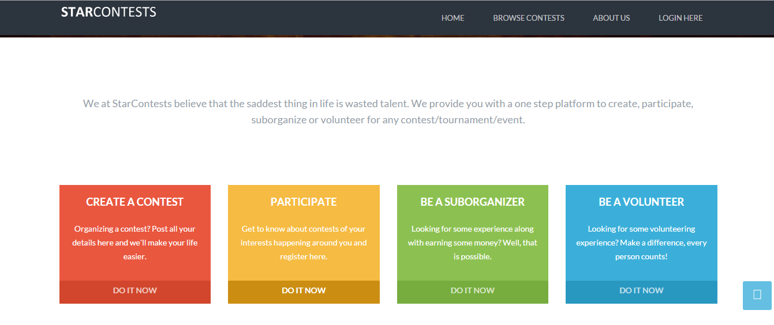

In this part of the home page you can see upcoming contests like sports, music, arts, classes etc. You can only see particular category by clicking on that category like sports, music, arts, food and drink etc.

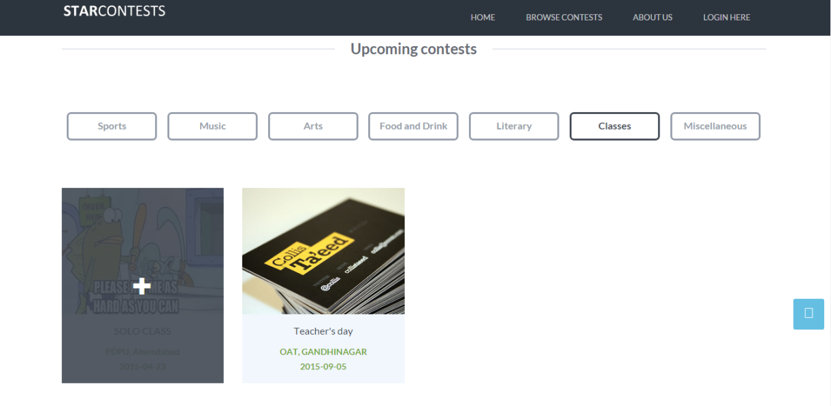

### ABOUT SECTION

This section shows the **About** section of our website and gives the users an option to email to star contests.

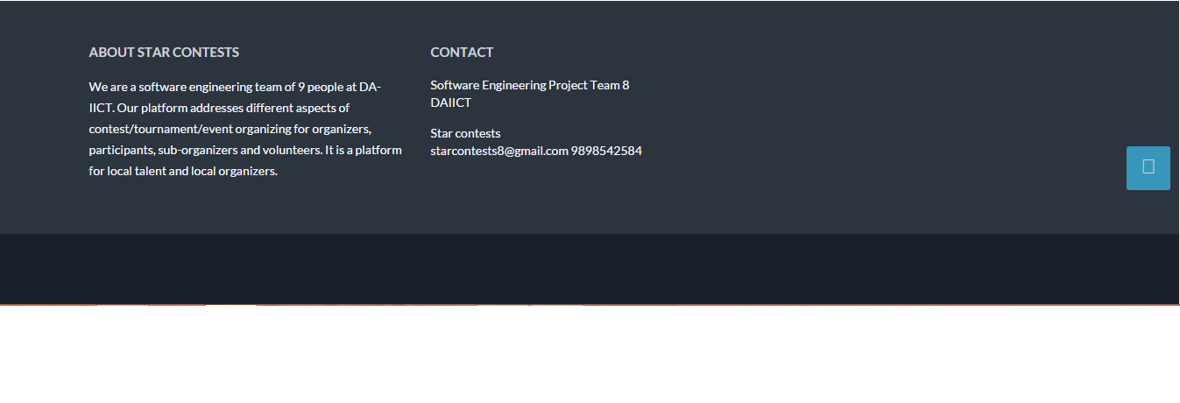

### Register Page (Sign Up)

New user has to register itself first to the register page.

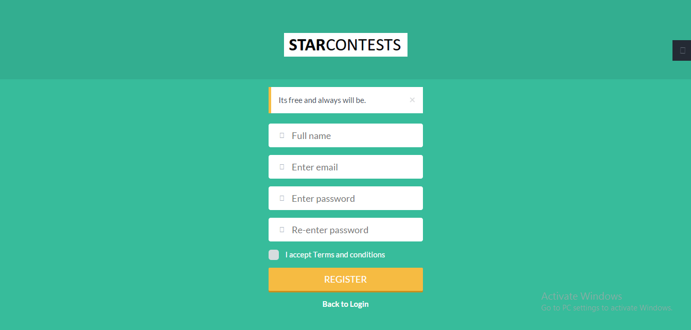

### Login Page

This is login page where user need to login with registered id to access the website.

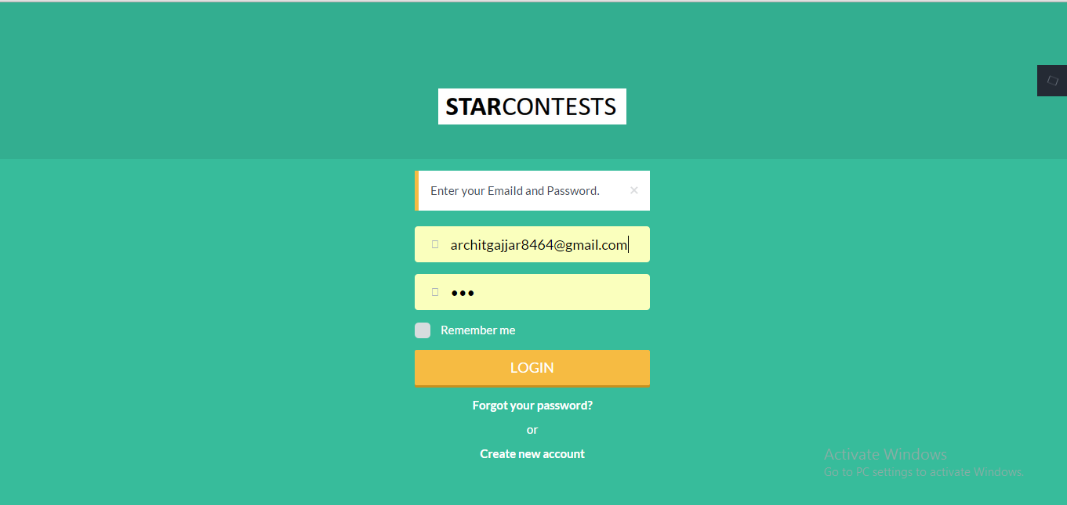

### Forgot Password Page

User can change account password if it is forgotten by clicking to forgot your password.

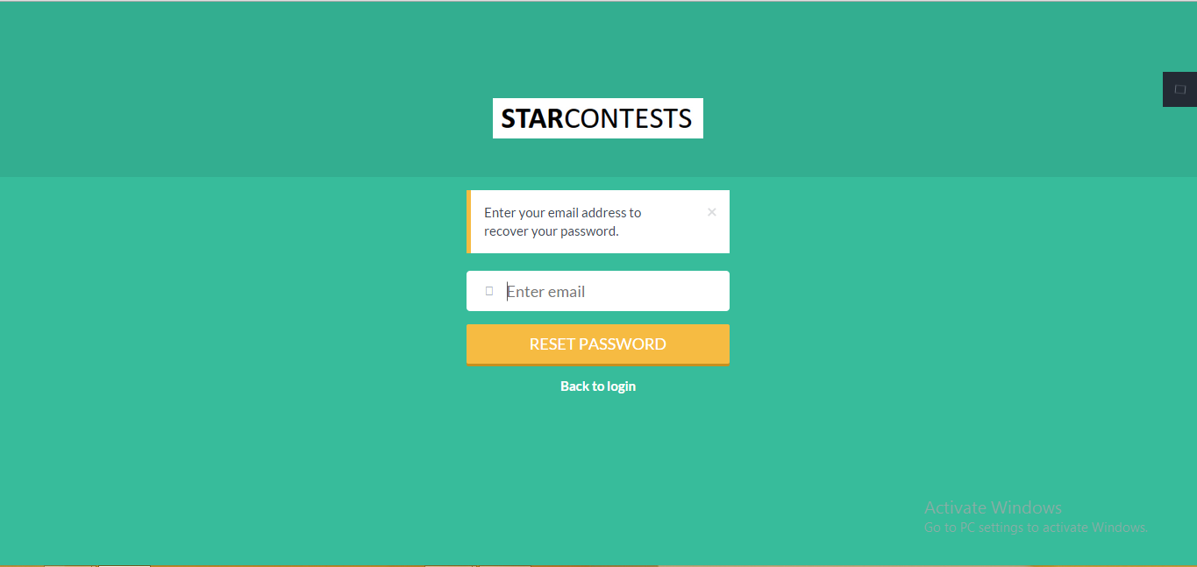

### PASSWORD RECOVERY MAIL :

The password recovery mail gives you detail of the new login with a new password which is randomly generated.

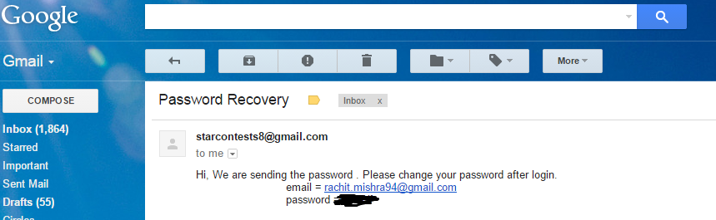

### Change Password

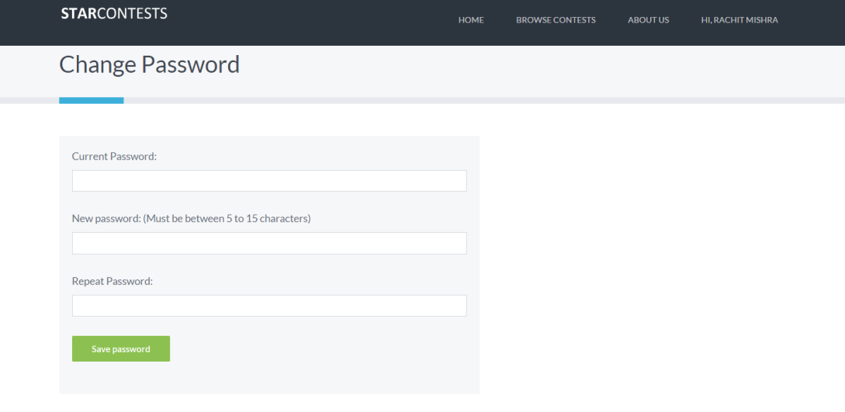

UPDATING THE PROFILE PICTURE :

The user can successfully update his/her profile picture. The **edit profile** button is available at the bottom of the profile page.

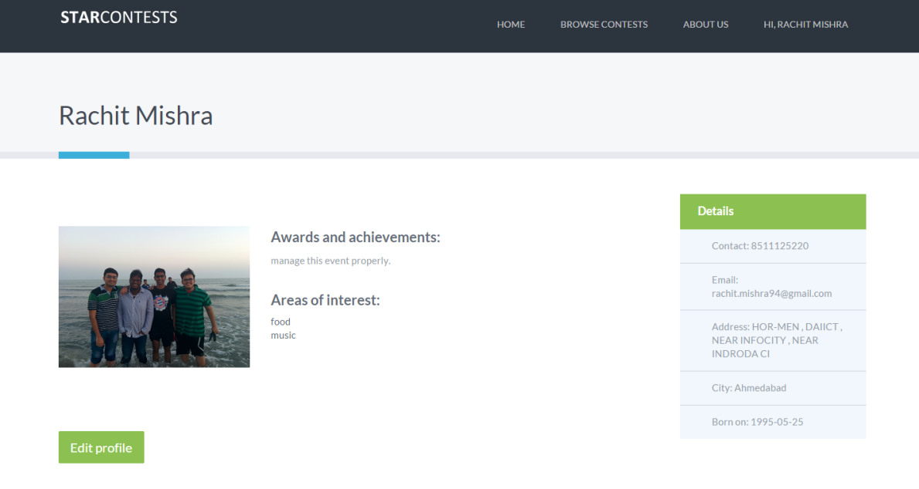

### BROWSING CONTESTS BY CITY

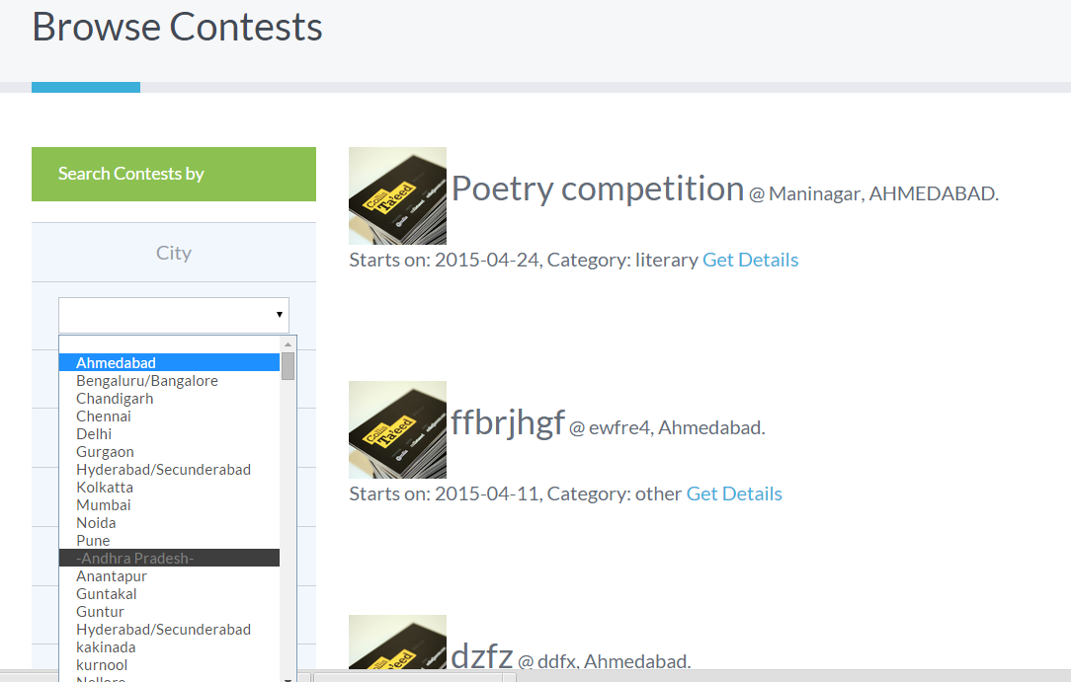

### BROWSING CONTESTS BY WEEK, MONTH or that day:

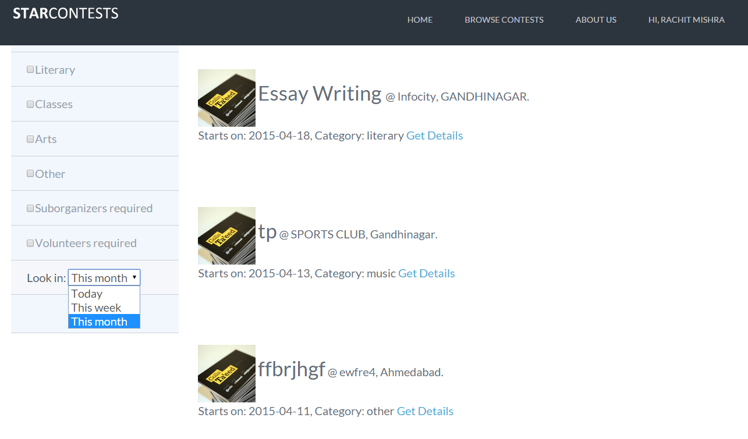

### BROWSING CONTESTS BY CATEGORIES:

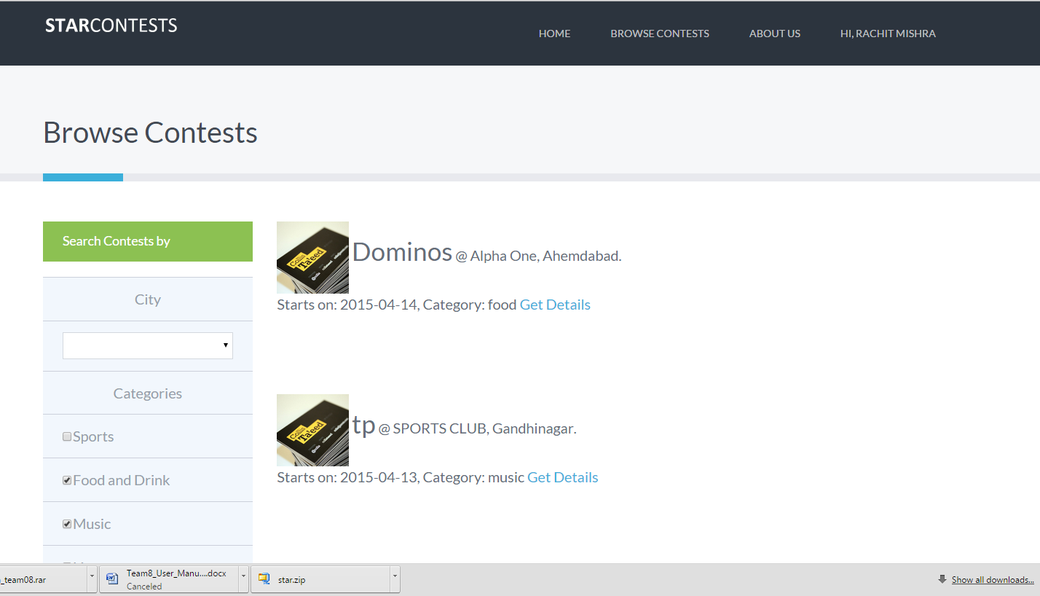

### A SEPARATE PAGE FOR THE ‘ABOUT US’ SECTION:

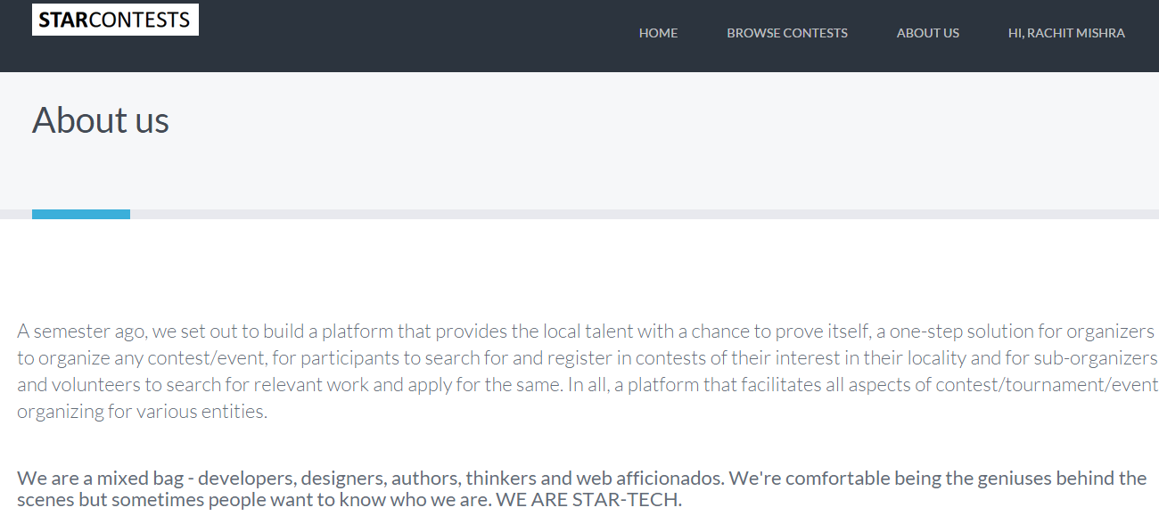

### Now moving on to the My Contest module:

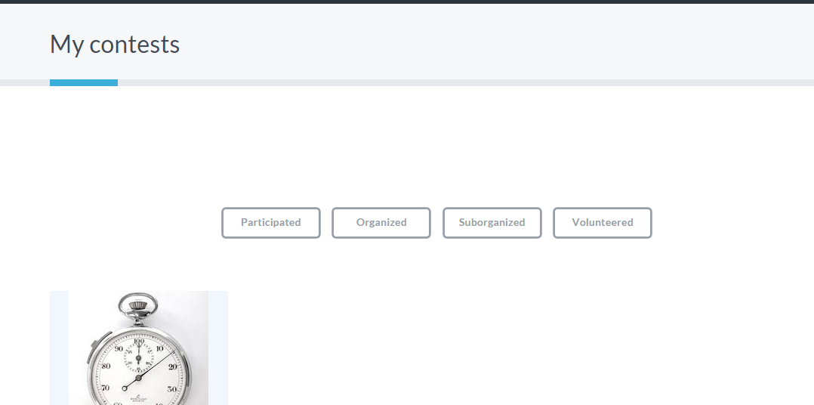

### EDIT YOUR PROFILE:

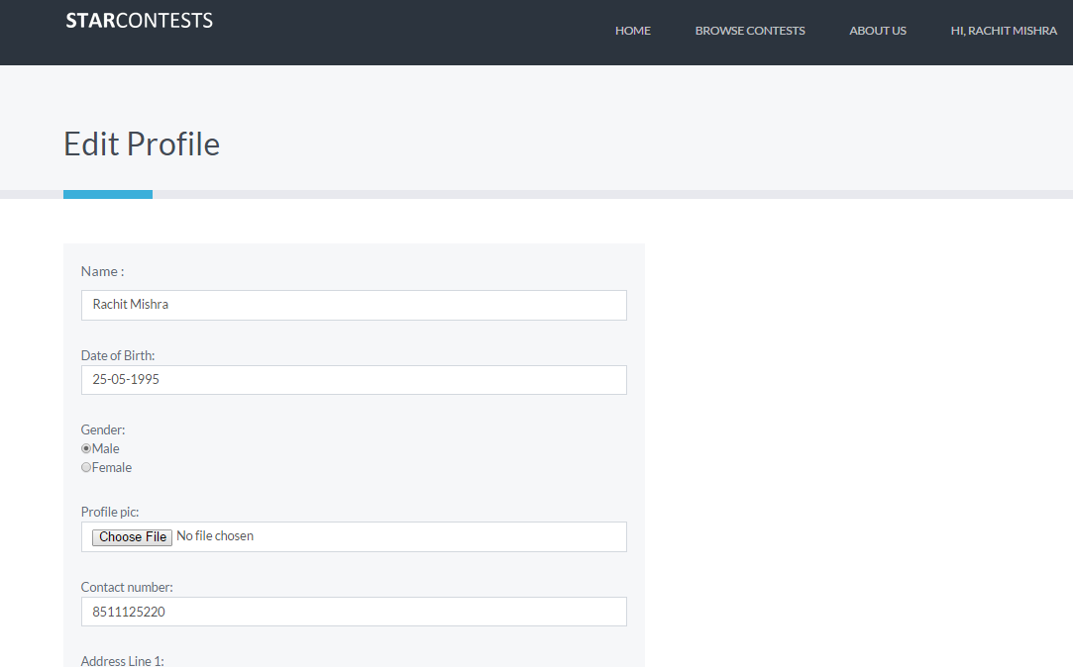

### EDITING THE INTERESTS SECTION AND SAVING THE PROFILE.

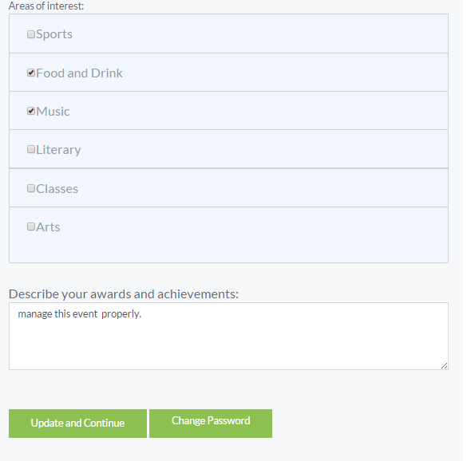

### NOW COMING TO ORGANIZING AN EVENT:



### Create Event

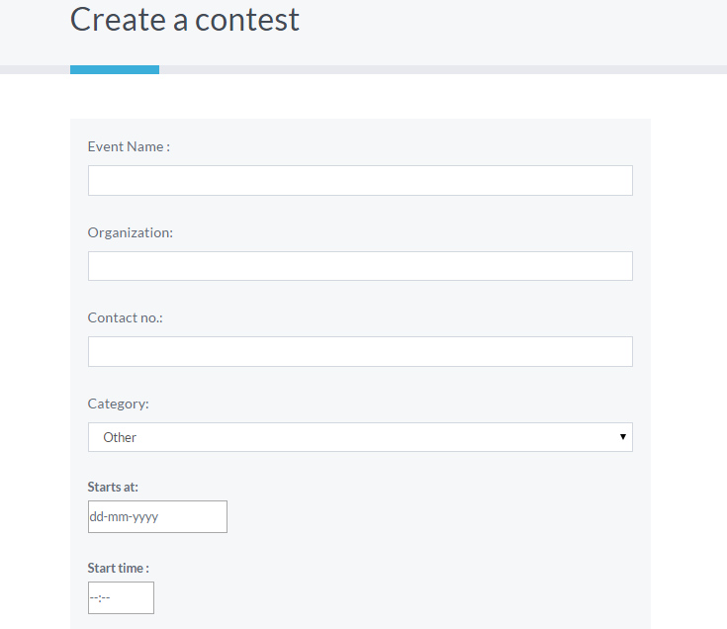

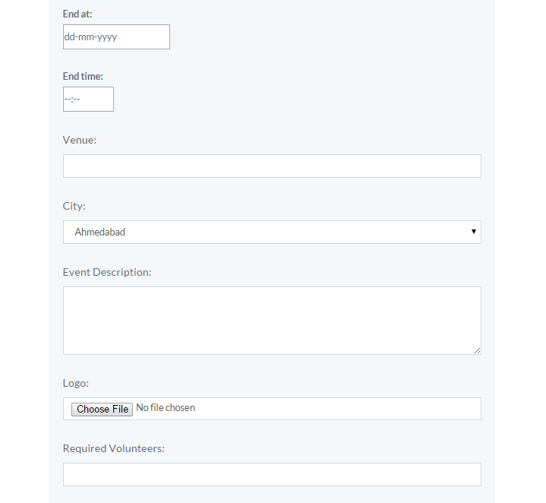

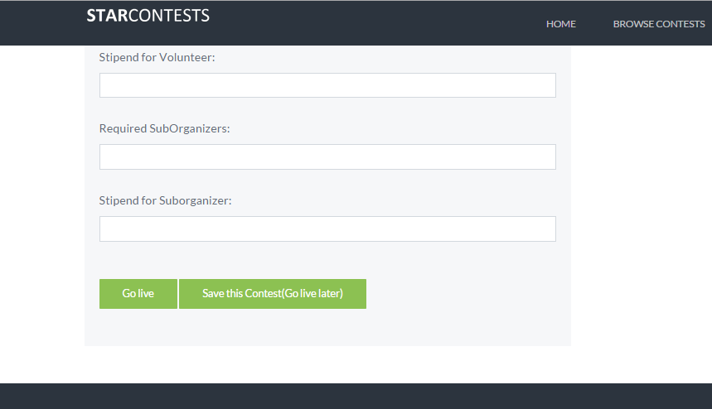

### The organizer can either make the event live or save the detail of the events and make it live later.

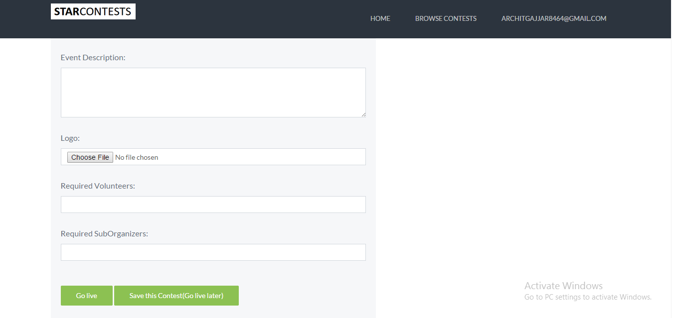

### MY COMMITTEE takes you to the chat thread between the organizers and sub-organizers. Also, it empowers the organizer by making him/her able to assign task to and download bills from volunteers/sub-orgs.

### 

### EVENT LOGO UPDATED

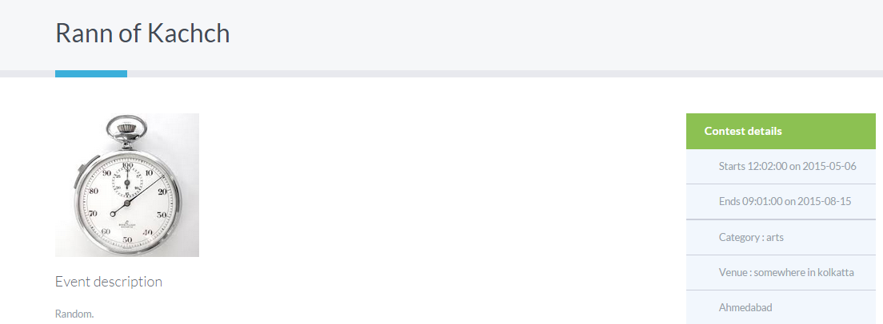

### EVENT SUCCESSFULLY UPDATED IN THE UPCOMING CONTESTS SECTION ON THE HOME PAGE

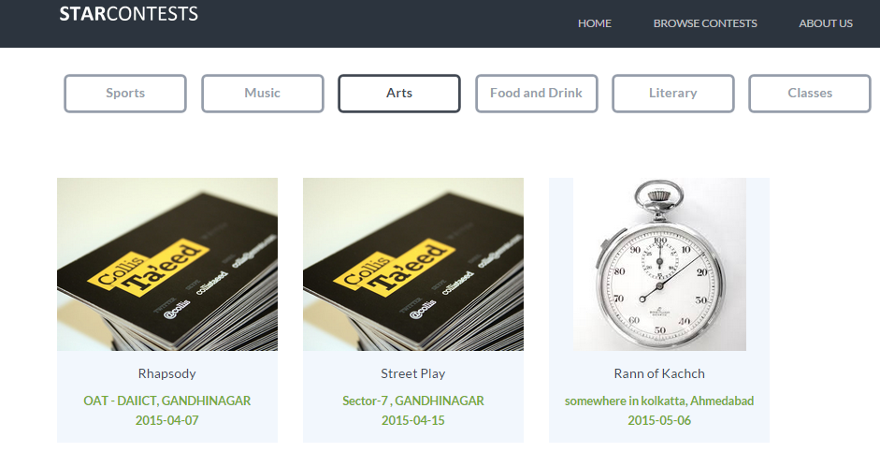

### EDITING CONTEST DETAILS

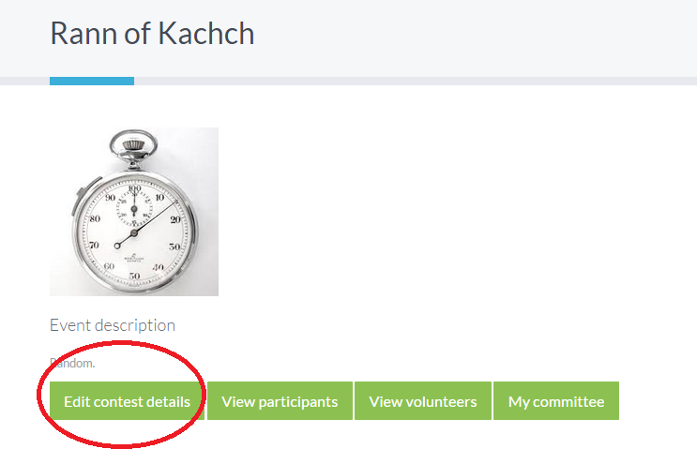

### Organizer can view the volunteers and the participants

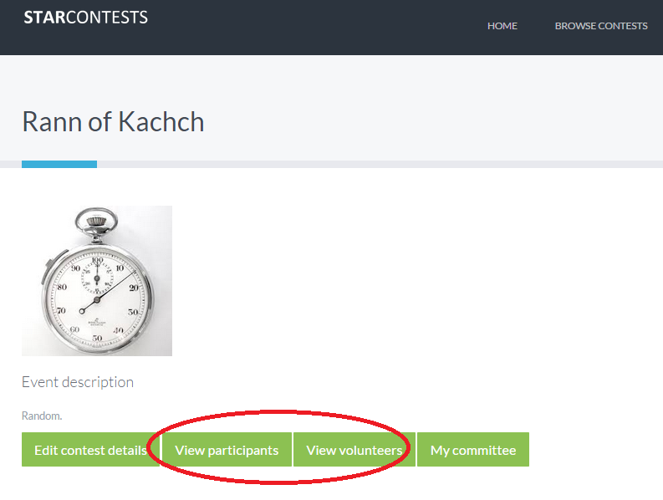

### Organizer can assign tasks to the volunteer or the sub-organizer and download bills uploaded by the sub-organizer or volunteer giving details of the events.

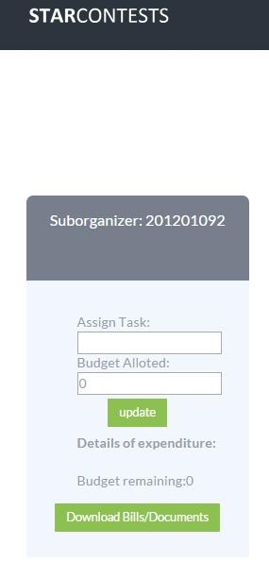

### On the sub-organizer or the volunteer side, where they can upload the bills or the documents.

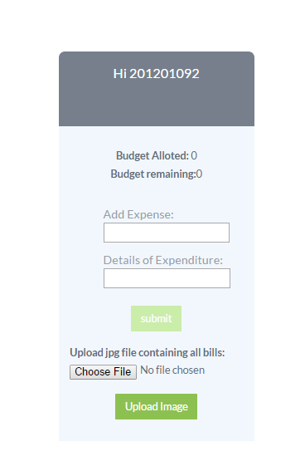

### ORGANIZER/Sub-organizer accesses the forum and chat with the volunteers or sub-organizers.

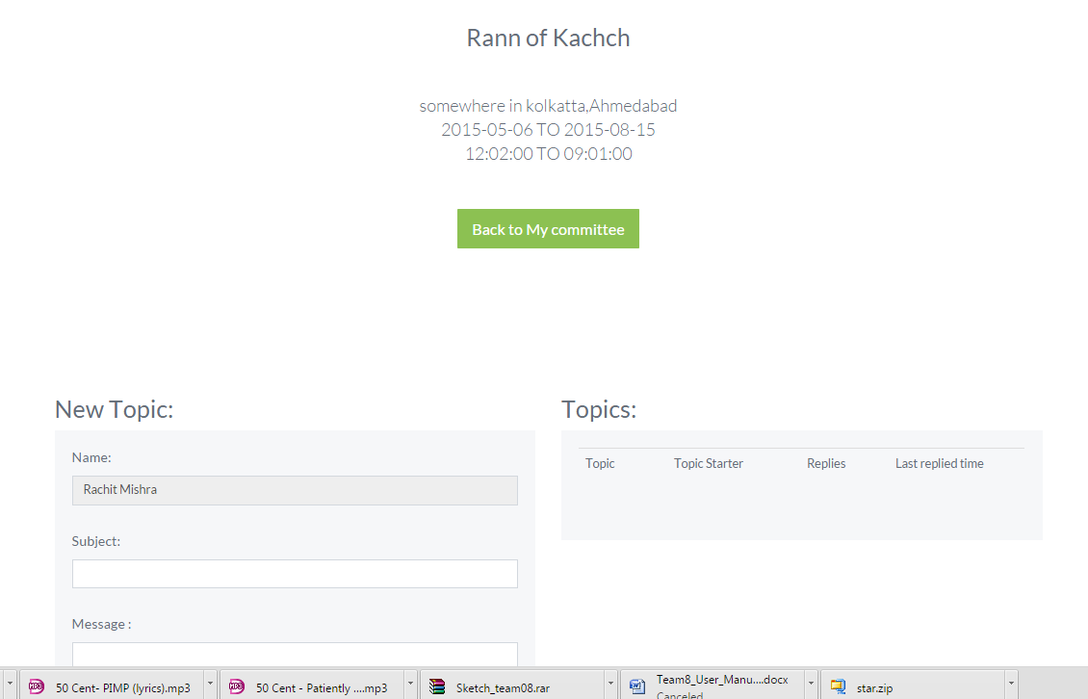

### ORGANIZER/SUB-ORGANIZER initiates a thread and starts the chart.

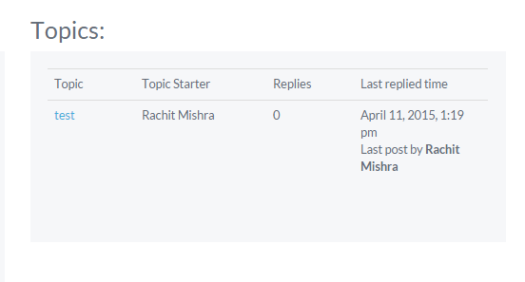

### Organizer/Sub-organizer/Volunteer can reply to the thread as shown below.



